A UKULELE BUYING AND CARE GUIDE
By Duncan Perry

I’m always excited to introduce folks to the ukulele. Here is some information to help you should you decide to buy a uke. I’ve also included information about electronic tuners, cases and gig bags and humidifiers.

There are lots of ukulele brands for the beginner these days, some really lousy, some very decent. You can buy a good beginner’s ukulele for a price in the $85-$300 range. Ukuleles traditionally come in three sizes: soprano, concert, and tenor. There are also baritone ukuleles which are usually strung, tuned and played like a tenor guitar.

Soprano (also called standard), concert, and tenor ukuleles are all tuned the same way and played the same way. Entry-level sopranos are the smallest and least expensive; they are good for small fingers, but ukuleles are not exceedingly large, so most people can play any size. Many sopranos have less volume than larger ukes and can sound a bit tinny. Sopranos generally have fewer frets (those spaces between the wires that cross the neck of the instrument) than their larger cousins but this is usually not a problem for beginners. Please note that the spacing of frets (the distance between those wires that I just mentioned) on the necks of ukuleles is widest on tenors and narrowest on sopranos. So, tenors are much more comfortable to play for folks with larger hands. Typically, adult uke plays prefer concert and tenor size ukuleles.

Here are the average total lengths of each size instrument:
Soprano: 21 inches with 12-15 frets
Concert: 23 inches with 15-20 frets
Tenor: 26 inches with 15 or more frets

Most wooden ukes come in the figure eight body shape and look like little guitars. You can also find pineapple shapes, that is, ukuleles with roughly oval body shapes (there are other shapes and materials too, including one that uses cigar boxes!). The figure eight is the more traditional looking model and is favored by most players. A variation of the figure eight has a cutaway section on the body near the neck meant to facilitate playing near the body of the uke. The cut away is not essential for beginning players and often increases the uke’s price. There are also banjo ukuleles available. They have four strings and are played like a wooden ukulele, although they sound much like banjos. Finally, there are resonator ukes for the blues aficionado, wooden or metal bodied ukuleles with a metal resonator cone implanted in the front of the instrument.

Some wooden ukulele models have a gloss finish, others have a satin finish or an oil finish. All are equally fine. Gloss finished ukuleles tend to cost a little more than those with a satin or oil finish.
Less expensive ukuleles are made with laminated woods -- very thin layers of plywood. More expensive ukes are made using solid woods. High quality solid wood ukuleles begin in the $300-$500 range and top out in the thousands of dollars. Most of the entry-level solid wood ukes are made is Asia. The high-end ones available in the US are made in the US and Canada. Solid woods impart a better sound quality in many, but not all, ukulele brands. There is nothing wrong with owning a laminate! I play several (though not at the same time, of course). In fact, having a quality laminate ukulele is usually the best way to get started. If you’re sure you want to get on the ukulele highway, then a uke with at least a solid top is best if it is within your budget. Good ones can be found in the $250-$350 range. If you simply want to try out ukulele playing without a major investment, decent entry level instruments are available in the $80-130 range depending upon size and maker.

When possible, visit a reputable musical instrument shop and try out different sizes, shapes and levels of ukuleles. Questions to consider are: What ukulele sounds best? What ukulele feels best? And, for some, what ukulele looks best? Compare the sound, feel, weight and finish of expensive ones to the low-end ukes. You may be surprised to find no big difference in sound among instruments in varying price ranges although the fit and finish will be more refined on the more expensive instruments.

Please don’t buy a ukulele online unless you know the dealer and can be assured of proper set up (making sure that the uke is in top playing condition when it reaches you) and service – or unless you are competent to do the work yourself. Buying from a local music shop is the best idea. Here are six shops where students previously have reported excellent service:

*Friendly River Music Shop *Nick's Midtown Music
40 River Road 571 Elm St.
Cornish, ME 04020 Biddeford, ME 04005
(207) 625-8639 (207) 282-0254

Buckdancer’s Choice *Ear Craft Music
248 St. John St. 432 Central Ave.
Portland, ME 04102 Dover, NH 03820
(207) 774-2219 (603) 749-3138

*Everyday Music *Musicians 1st Choice
205 Broadway 246 Western Ave
Farmington, ME 04938 Augusta, ME 04330
(207) 778-3483 (207) 632-0400

**Northern Kingdom Music
349 Harlow St
Bangor, ME 04401
(207) 947-6450

Shops named above with an asterisk (*) beside their name offer discounts to my students; (**) may give discount or special offer. Be sure to mention that you are taking my class.

My preferred ukulele brand choices for beginners are: KALA, OHANA, and ISLANDER by Kanile’a. I recommend going online to check out their web sites to get a sense of the ranges of ukuleles they make. Decide what you like, call a music store to see if they carry it, and if they do, check it out and while you are there, try comparing your choice to others for sound, feel, and construction. Below are the URLS for these manufacturers:
https://kalabrand.com
https://ohana-music.com
https://www.islanderukulele.com/shop/

Other moderately priced, reputable brands of ukuleles include:
- Amahi
- KoAlana by KoAloha
- Oscar Schmidt
- Cordoba
- Lanakai
- Luna
If you really want to buy on-line, here are four reputable dealers. But, understand that you will pay shipping (unless they are having a special or unless you buy a pricey ukulele) and that having service and repairs done long distance is a VERY BIG nuisance.

The Ukulele Site: http://www.theukulelesite.com
Elderly Instruments: http://www.elderly.com/departments/ukulele
Bernunzio Uptown Music: http://bernunzio.com/category/instruments/ukuleles/
Sweetwater: https://www.sweetwater.com

CASE/GIG BAG, TUNER and HUMIDIFIER
Please note that it is important to also buy a case or gig bag to protect your ukulele. Music stores carry cases and gig bags of varying quality. For a beginner’s ukulele a gig bag that is reasonably well padded is a good option. Make sure the zipper works well. Kala, Lanikai, Levy, and Uke Crazy are good brands, but because ukulele bodies vary in size and shape by manufacturer, even within the size categories – soprano, concert, and tenor – it is best to try out the case or gig bag to make sure your ukulele fits well. You should be able to buy a decent gig bag for about $35. Foam core cases offer more protection and are in the $50 range. Hard shell cases begin around $79.

It’s important to have an electronic tuner or at least at tuner app. You can find apps for your i-phone or you can buy an electronic tuner such as the Kala Ukulele Tuner, Intellitouch PT-20, or one of the Snark tuners. These clip onto the peg head of your ukulele – where the tuning knobs are – and enable you to efficiently and accurately tune your instrument.

It is also important to insure proper humidity for your ukulele. The ideal humidity level for happy ukuleles is in the 45-50% range. Below 35% and you risk drying out the uke, shrinking the wood, cracking it or worse, above 65% the wood can swell a bit and distort sound. During winter months especially, when our homes tend to have low humidity, wooden instruments can dry out, though excessive air conditioning can seriously lower humidity too, during summer.

A small in-case humidifier can protect your investment, although you need to keep a weather eye on it to be sure the humidifier remains moist. Herco’s clay humidifier priced at around $4.00 is the cheapest and is a good choice for use with inexpensive ukes. D’Addario makes reasonably priced cigarette pack shaped humidifiers for around $10 that I use with my several of my ukuleles. Music Nomad and D’Addario make a humidifier that inserts in the sound hole and is held in place by the strings for $10-$14 – these are a good choice, especially for all wood ukes. Oasis offers one that inserts in the sound hole and extends into the interior of the body; it is held in place by the strings. This is the premium humidifier and as such costs $18-20. All are available on-line and in most musical instrument shops.

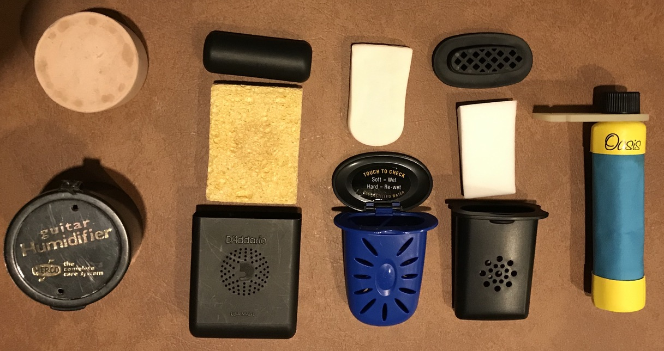

MY RECOMMENDED CHECKLIST WHEN BUYING A UKULELE
- Buy from an established local dealer who services and stands behind what the store sells if you can.
- Select a ukulele that you think sounds and feels good.
- Make sure the dealer performs an inspection to insure that the uke is in top playing condition, with the strings set up properly, and that the physical condition of the instrument is prefect (good finish -no cracks, dents, dings - straight neck, no jagged fret wires).
- Don’t forget to get a case or gig bag to protect the instrument.
- Buy an electronic tuner or add an app to your cell phone.
- Buy a humidifier and use it with distilled water during late fall, winter and early spring.
- It is good, but not essential, to buy a music stand – inexpensive ones can be purchased online.

Please feel free to be in touch with me if you have questions! My email is uketime24@gmail.com
or 219-8055.

8/10/21

